Out of time
A BELOVED COACH HOPED AN UNPROVEN STEM CELL THERAPY COULD EXTEND HIS LIFE. BUT THE CLOCK IS RUNNING OUT TOO FAST.
The Facebook post late Thursday night landed like a punch to the gut to everyone who knows Jeff Dienhart.
The beloved Central Catholic girls assistant basketball coach, who has been waging a fierce struggle against the suffocating ravages of cystic fibrosis, abruptly announced that the end is now near.
"I was sent home today from the hospital on hospice care. I received the sacrament of confession and the anointing of the sick last night from father Daniel garland. I am at home under medication. Could have days could have weeks could have months no one knows. Just know I am at peace. I am scared and dont want to leave this place on earth.. I have fought so hard for so long. I am so tired and have suffered so much this year .please pray for my wife Valerie my daughter Alicia and my son drew during this tough time."
It was not supposed to end this way. Dienhart was, in fact, just days away from an experimental stem cell treatment that he hoped would extend his life. Friends, family and the community had raised more than $70,000 to cover the costs.
And Dienhart, 44, had beaten so many odds before.
The statistics suggest, for example, that many men with cystic fibrosis are infertile, yet Dienhart fathered two children.
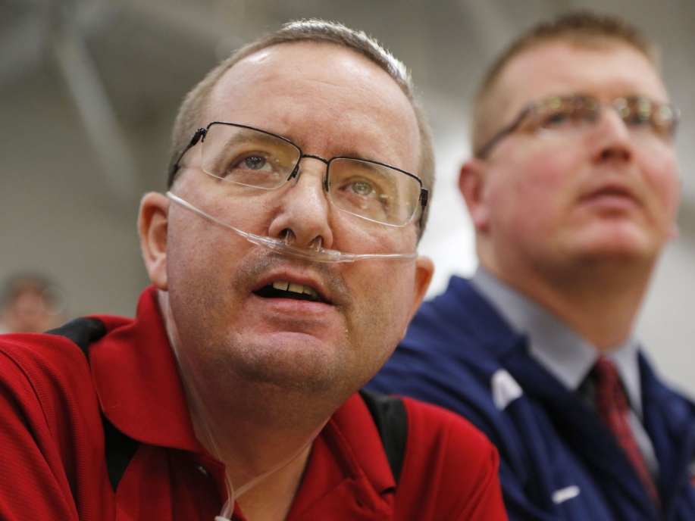
Central Catholic assistant girls basketball coaches Jeff Dienhart, foreground, and Dave Crandall watch the action as the Knights host Guerin Catholic on Jan. 30. It was the first game for Dienhart in quite a while, as he had spent the better part of the month of January in the hospital. Dienhart is set to receive stem cell treatment in the Dominican Republic to hopefully assist in his battle with cystic fibrosis.
(Photo: John Terhune/Journal & Courier)
Nor were CF sufferers supposed to be able to play marathon rounds of golf.
"I would tell the doctor he played 36 holes of golf in 90-degree heat," said Dienhart's mother, Kathy Dienhart. "The doctor would tell me I made that up. My husband and I came to the conclusion that he is a fighter. Odds don't mean anything to him."
All of which went some way toward explaining why Dienhart was ready to take the riskiest gamble of his life, to try to extend his life.
He was preparing on March 1 to board a plane to the Dominican Republic. There he was to hand over $57,000 to a former cardiologist whose medical license was revoked for malpractice by the state of Florida.
Then Dienhart was going to submit himself to an infusion of adult stem cells that is unapproved in the United States but that proponents believe can improve lung function in those afflicted with cystic fibrosis. Two of the former cardiologist's patients died soon after undergoing the procedure.
Dienhart knew all of that. He said he understood the risks. Yet he was determined to go forward — and return to Indiana in time to see his beloved Central Catholic team compete in the state finals on March 7 in Indianapolis.
"I owe it to myself to pretty much cross off every option possible," Dienhart said a few weeks ago, the tubes from his oxygen tank shifting slightly near his nostrils as he began to speak. "I guess I am going to find out if this is a scam or if it works."
Now, he'll never get that chance.
A life with CF
Countless hospital trips. Constant coughing. Waking up each day to a series of breathing treatments and medications, as many as 12 taken orally. A valve that must be blown into four times a day to loosen mucus. Lung function about 15 percent — while on oxygen.
That was the reality of Dienhart's continuous battle with CF, a life-threatening genetic disorder that affects about 30,000 Americans and killed more than 400 in 2012, according to the Cystic Fibrosis Foundation. He was diagnosed with the disease at age 17.
Cystic fibrosis causes the body to produce a thick, sticky mucus that clogs the lungs and obstructs the pancreas, interfering with the breakdown of food and absorption of vital nutrients. There are limited treatments available, and no cure.
Yet even as Dienhart managed to keep the signs of CF mostly hidden from the public, people knew. His shoulders sometimes were noticeably higher when his body pulled them up to compensate and try to open his airways.
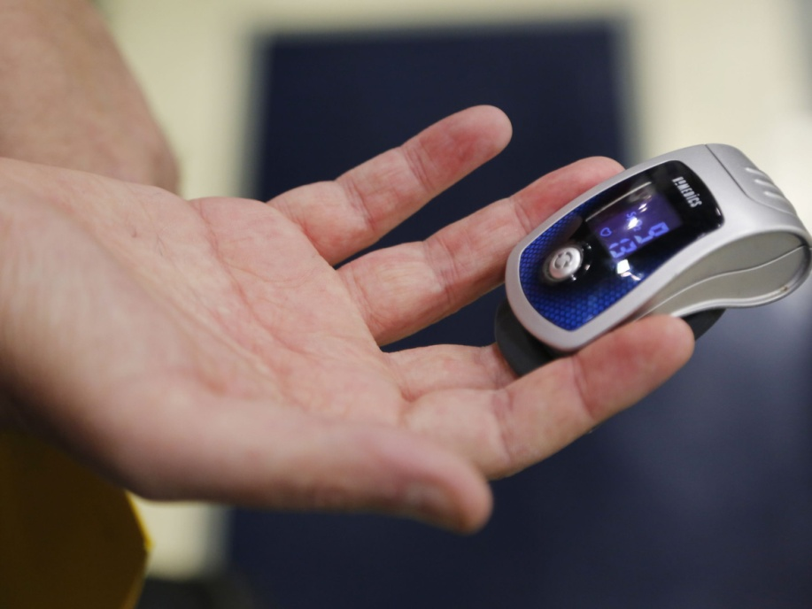
Dienhart checks his blood oxygen content.
(Photo: John Terhune/Journal & Courier)
Morgan Hainje is best friends with Dienhart's son, Drew. She played basketball at Central Catholic.
"I knew Drew's dad was sick, but it wasn't something we talked about," Hainje said. "If you met him, you would never know anything was wrong with him."
At age 25, Dienhart suffered his first infection and was forced to use intravenous antibiotics. He would never again feel as good as he did prior to that day.
"I noticed a decline in my breathing and lung capacity to where I couldn't go out and play sports like I used to," he said. "I could no longer play basketball or softball. I couldn't breathe. I would get worn out quickly, short of breath all the time."
So Dienhart started other sports. Bowling and golf he found less strenuous. About two years ago, even those hobbies became too much.
But he still had basketball, even if it was just from the sidelines.
Coach Dienhart
Dienhart knew what he wanted to be when he received his diploma from Central Catholic High School in 1988. He dreamed of becoming a teacher and a high school basketball coach.
Instead, he said he did what many teenagers away from home for the first time do. He "had too much fun" at Indiana State, returned home and commuted to Purdue University.
"I realized school wasn't for me," he said. "I didn't have the self-discipline to do what I needed to do."
He did become a basketball coach, joining coach Tim Riehle's girls basketball staff at CC at age 21, then later stepping away when his son Drew was born. Five years ago, he rejoined the team on coach Pat Tharp's staff and remained ever since, even after Tharp's resignation and the hiring of Craig Devault in 2012.
Coaching came naturally and at an early age.
"My brother Dan and I were both very active in basketball at CC, and Jeff obviously couldn't participate in a competitive nature like that," said Dienhart's brother, Erick Dienhart. "Jeff was always there to help us and give us pointers. Coaching was definitely an avenue that was a natural fit for him."
It made sense. Wayne Dienhart, the patriarch of the family, was a Lafayette postal carrier who coached football and basketball at Central Catholic.
"When (Jeff Dienhart) was a freshman in high school, he was so short and little and he didn't get to play as much as he used to," Kathy Dienhart recalled. "His basketball coach told me he liked having Jeff sit on the bench next to him because Jeff knew more about basketball than the coach did."
On the bench, Dienhart found comfort and could forget, at least for a while, about his bouts with cystic fibrosis. In the gym, it was all about the girls on the team.
"He is a very selfless man. He really tries to give to everyone, and he doesn't expect anything in return," said senior guard Angela Tharp. "He is probably one of the nicest guys I know."
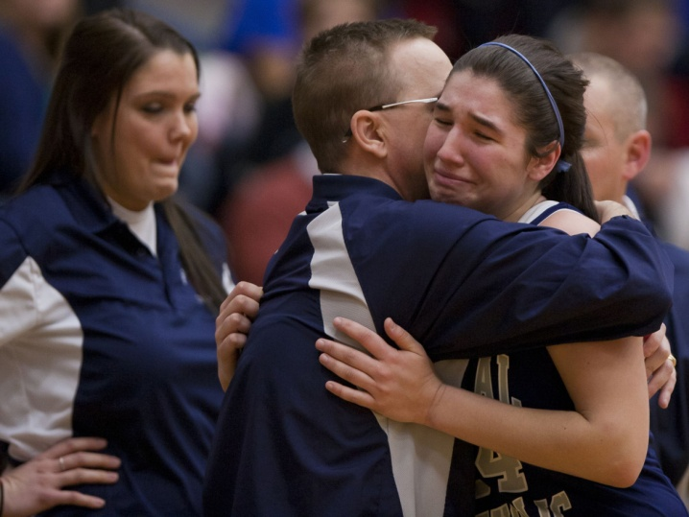
Dienhart hugs Alanna Roswarski in the closing seconds of their 2013 semistate game against Fort Wayne Canterbury at Crown Point High School in Crown Point. Players cite him as a coach who always offers support — the guy who will tell you “Nice job” when it’s deserved and calmly advise you when it’s not. Whenever Dienhart takes players aside, they can count on hearing words of encouragement.
(Photo: File photo/Journal & Courier)
Players cited him as a coach who always offered support — the guy who would tell you "Nice job" when it was deserved and calmly advise you when it was not. Whenever Dienhart took players aside, they could count on hearing words of encouragement.
Or at least, they used to. In recent months, his encouragement had gone mostly unheard because his voice was not as boisterous as in past seasons.
"He sits on the sideline and just watches and tries to instruct the girls, but they can't hear him," Devault said. "I know that hurts him a lot."
Last season was the first time Dienhart's illness kept him away from the team.
"I ran into some complications where I coughed up a lot of blood, lost a lot of blood," Dienhart said, recalling an especially rough period a year ago. "Shortly after that, I had to be re-hospitalized due to an infection. I've never fully recovered from that and had to start using oxygen."
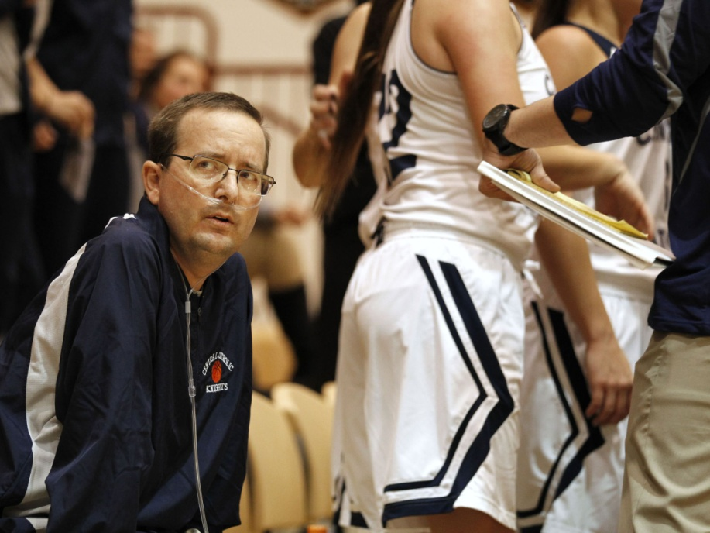
Central Catholic assistant girls basketball coach Jeff Dienhart looks to the scoreboard during a break in the action of the J&C Hoops Classic. Dienhart is hooked to an oxygen tank as he suffers from cystic fibrosis, a genetic disorder that affects the lungs. He is about to travel to the Dominican Republic for a controversial stem cell procedure that is not approved by the United States Food and Drug Administration.
(Photo: John Terhune/Journal & Courier)
After all the support he gave the players, it was Dienhart who came to rely on it.
"I can show you some quotes and letters from former players. Now they are supporting me. They are my inspiration to keep fighting," Dienhart said. "They use me as motivation, but I will be honest with you, I need them more than they need me.
"That is really my main reason why I coach. It's not about wins and losses. It's about the relationships you develop with student-athletes, not only on the court, but in life off the court."
Of course, winning is fun, too. And that was a major factor in his return to the sideline this season.
He's been a part of two state championship baseball teams, but as the Knights' official scorer. He was just along for the ride.
The Class A girls basketball state championship game will be played at 10:30 a.m. March 7 at Bankers Life Fieldhouse in downtown Indianapolis. Dienhart's goal was to be there on the bench.
Without a certainty of how many games he has left to coach, Dienhart made the trip to Tri-Central on Saturday for the regional, where he was wheeled to the bench before taking his familiar place near the scorer's table. After a semifinal victory over Monroe Central, Dienhart was greeted by several CC fans who showed an outpouring of support.
Good Samaritan
Dienhart has a tattoo over his heart. The tattoo is of a newborn child lying in wings. Above it is the inscription "8-29-13" and below it is the name Tyler "TJ" Jeffrey.
TJ died at birth on Aug. 29, 2013.
In his memory, Dienhart gave each graduating senior member of the CC girls basketball team who's been with the program at least three years a gift to be used for postsecondary education.
Each senior received $829.13, a figure that signifies TJ's date of birth and death.
"I hope to do it forever," Dienhart said recently.
Emily Denhart was the first recipient of the scholarship last year. She's using it to pay for books at DePauw University.
"He is a very selfless person in all aspects of his life," Denhart said. "That shows through everything he does."
Many others offer similar testimonials.
Emily Tharp had doubts about playing volleyball for her senior season. She leaned on Dienhart for guidance. He encouraged her to stick it out. She ended up starting in the 2013 state championship match.
"His commitment to his team, his passion behind the game, his love for every player is something I could never forget," she said. "He's a coach who doesn't just teach the plays. He taught us so many life lessons that I keep with me as I am now in college. I can't even put into words the kind of man he is."
Here's another measure of Dienhart's impact on his school and community: $70,000. That's how much money was generated at several fundraisers to help the coach cover the costs of the experimental stem cell treatment, which would not have been covered by insurance.
It was actually more than he needed for the procedure and related travel costs. He vowed that, if he were to die before using all the funds, they would be redistributed to people in need, just like him.
"I made a comment to my mom after meeting with the doctor that I probably only have 10 really what I would call good friends," Dienhart said. "Little did I know, I have hundreds of people who have shown support. Total strangers I have never even met have donated money to the cause. It is very overwhelming. There are no words to describe how I feel. It's very humbling.
"You can never say thank you enough and be able to repay these people," he continued, "other than to keep fighting to improve and to hopefully get better and let them see the reward they gave me."
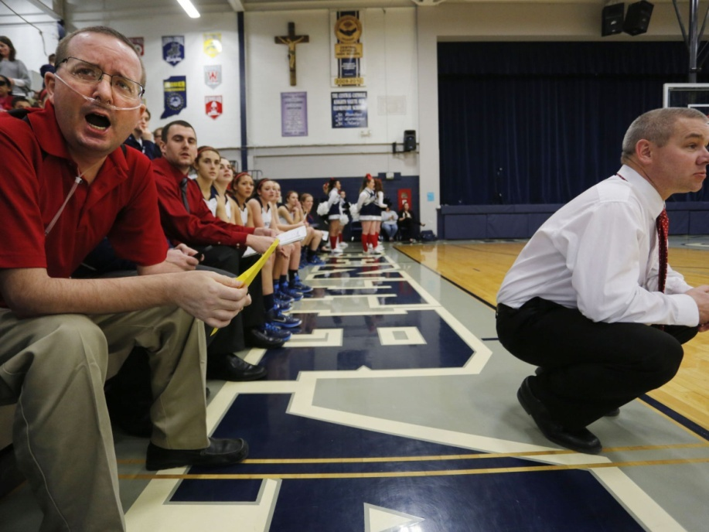
Central Catholic assistant girls basketball coach Jeff Dienhart, left, shouts encouragement to the Knights. At right is coach Craig Devault.
(Photo: John Terhune/Journal & Courier)
The procedure
About 11 years ago, Dienhart said, he was told by a doctor that if he did not undergo a double lung transplant, he would be dead within 18 months. After becoming stable, Dienhart eventually removed his name from the transplant waiting list.
His condition remained stable until his setback in February 2014, when a doctor gave him a new timeline to live: two years.
"He said I would be on oxygen 24/7 the rest of my life. I told him at the time, 'Well, I am out to prove you wrong,'" Dienhart recalled. "I started pulmonary rehab in May and by June, I was able to be off oxygen without exertion. Even during summer league basketball games, I could sit on the bench and coach and not use oxygen."
But another infection last July forced Dienhart back onto oxygen. He's been dependent on it ever since.
Determined to help her husband any way she could, Dienhart's wife, Valerie, came across the website of a Florida company, Regenocyte, that promotes stem cell treatments for a variety of diseases and disabilities, ranging from multiple sclerosis and cardiovascular disease to traumatic brain injury and spinal cord injuries.
On a page titled "Stem Cell and the Treatment of Cystic Fibrosis," Regenocyte says this:
"If you or a loved one suffer from Cystic Fibrosis, therapies using adult stem cells may restore your quality of life to a previously unexpected level. Because adult stem cell therapies are safe, simple, and non-invasive, they particularly help those who have exhausted the possibilities of other treatments."
Dienhart was skeptical. But his wife said she'd rather he try it and see it fail than spend a life wondering "What if?".
The theory behind the procedure is straightforward: Adult stem cells extracted from matching donors — in Dienhart's case, his son Drew and a brother Erick — were to be mixed with Dienhart's own stem cells and then cultured in a solution in which they would grow. Then the mixture was to be infused back into Dienhart's body, where the stem cells were supposed to regenerate damaged lung tissue.
Mixing a patient's stem cells with donor stem cells "helps donor cells fly under the radar," according to Zannos Grekos, the former cardiologist who developed the procedure and was to administer Dienhart's treatment. "If the cells are not matched, the body will see them as foreign and reject them."
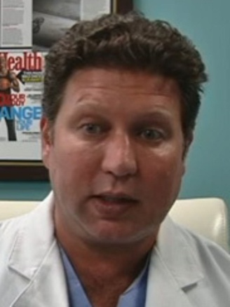
Zannos Grekos
(Photo: File photo/The News-Press)
Dr. Shihuan Kuang, who teaches a course in stem cell biology at Purdue University, said he sees logic behind the procedure.
"In theory, the stem cells, if they can land in a crack to do what it they are supposed to do, should make copies to basically make it last," Kuang said. "Even if it's only three or five years, that's still a long time compared to the normal rate. Eventually, the stem cell will deteriorate."
But the theory is far from proven. The Food and Drug Administration has ruled that adult stem cells constitute a drug, rather than human cell and tissue products, and therefore must go through FDA testing for approval. Such approval has yet to be granted for any adult stem cell procedure.
Other experts in the field are skeptical of anecdotal evidence purporting to show benefits from adult stem cell therapy.
"These stories are deeply concerning to me," said Dr. George Q, Daley, director of the Stem Cell Transplantation Program at Children's Hospital Boston. "While I feel for the coach, he's being sold false hope that comes with great risk for more than just financial loss — the risk of threatening infections, blood clots and allergic-type reactions.
"As described, this infusion of cells from himself and two relatives is unprecedented in my experience and has no credible rationale."

